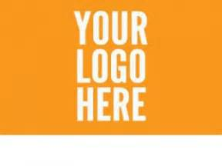

MEDIA RELEASE/CONSENT FORM

I give my prior and informed consent to participate in recorded interviews and/or have my photo taken for the <YOUR ORGANISATION> event <YOUR EVENT NAME> on …./……/…….. and for this material to be used by <YOUR ORGANISATION> and /or other media channels for the purpose of news stories, advertising, promotion and /or advocacy.

I have read the above and fully understand its contents. I hereby grant permission for my /my children’s participation in <YOUR ORGANISATION>’s <YOUR EVENT NAME> and use of filmed material by <YOUR ORGANISATION> and /or media channels

Please circle A or B below

- A: I am 18 years of age or older OR
- B: I am the parent or guardian of a minor

NAME OF CHILD:…………………………………………………………………………..
RELATIONSHIP TO CHILD:………………………………………………………………

NAME………………………………………………………………………………………….
Signed:…………………………………………………….……………DATE …../…./…….

