# HOW TO CREATE A FACEBOOK PAGE IN 8 STEPS

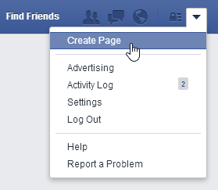**Step 1: Create A Page**

To create a Page, log into your personal Facebook account. Click the arrow in the top-right corner of any page and then select Create Page.

When you use your personal profile to set up your organisation’s Page, you will automatically become the Page admin by default. The Page admin is the only one who can change how the page looks and share updates.

Nobody visiting the page will know that you are the admin. Your admin role won’t affect the privacy of your personal profile and won’t appear in your Page’s posts or other activity.

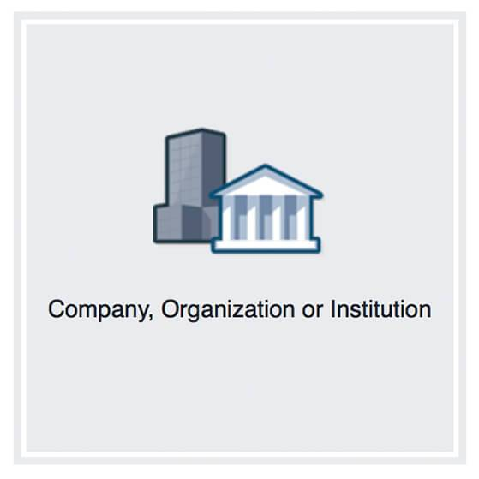

**Step 2: Choose A Page category**

Choose ‘Company, Organization or Institution.’ You don’t have to be a registered nonprofit to list your Page in this category. You can choose one of many sub-categories for your Page in the dropdown menu, including Community Organization, Non-Profit Organization, NGO, Education, and more.

[Note: Do not choose ‘Cause or Community,’ it won’t have access to the exclusive tools Facebook has made available to nonprofits]

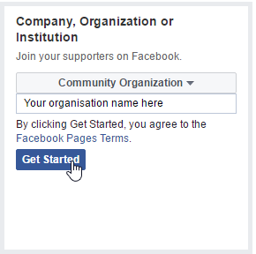**Step 3: Enter your organisation name**

Write the name of your organization in the box, and then click ‘Get Started.’

#### Step 4: Show people what your organisation is about

Add a Cover Photo – When you click on this button, you will be asked to upload a phot from your computer. Use a large, high-quality image. If possible, use a photo showcasing your organisation’s activities, for example you could use a photo of a recent event or meeting.

Add a Profile Picture - Your profile picture is a way to help people recognize your brand when they see a post from your Page in News Feed. We recommend a square version of your organization’s logo. Keep in mind, it’ll often appear small.

Add a Short Description - This is your chance to give people a quick preview of what your organization does. Briefly state the mission of your organization and the impact your programs create.

Create a Username for your page - A username helps people find and remember your Page. When you create a username, it appears in a customized web address (ex: facebook.com/yourorganisation) for your Page. Your username should match the name of your Page as much as possible.

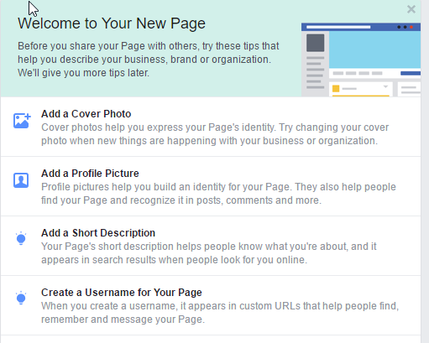

**Step 5: Enter your Business and Contact Information**

Next you should click on the **‘About’** page on the left-hand menu. Here you can enter important information about your organisation.

Edit Mission – Click on this to share your organisation’s mission. Make sure to share your organisation’s mission statement so that people can understand what you do and why you do it.

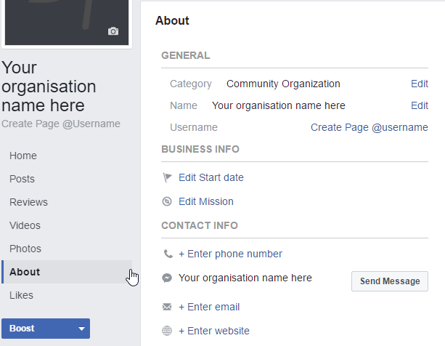Enter phone number/email/website – This is how people will be able to contact you. Don’t worry if you don’t have a website, you can still share the phone number and contact information of your organisation’s spokesperson.

**Step 6: Adding Page admins**

After you create a Facebook page, you will be the only person who is allowed to edit the page information and post updates to the page's Timeline. However, if you'd like to give other people permission to do these things, you can add them as page admins. To add a page administrator, click Settings near the top-right, then select Page Roles on the left-hand menu.

Under Assign a New Page Role, enter the name of the person you want to make an admin. If they are on Facebook, their name will appear in the drop-down menu.

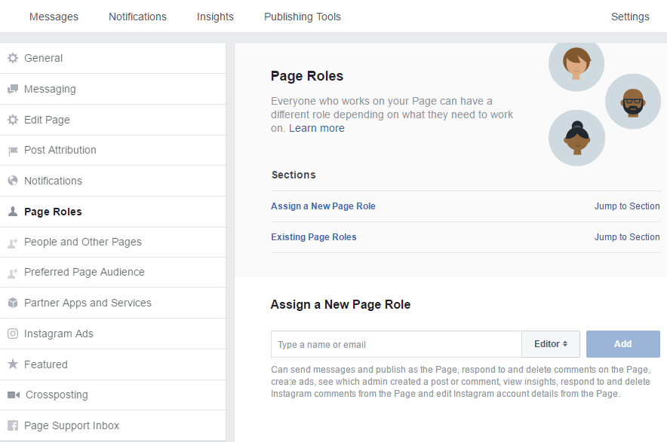

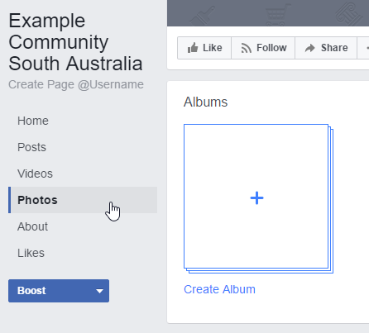**Step 7: Add Photos and videos!**

Adding photos and albums to your Page will make it look interesting and help show people the work your organization does and the impact you create. When you upload a photo or album, your supporters will see it as a post in News Feed. If you have videos that showcase your organization’s work and mission, add those here too. Some additional tips:

* Add descriptions to your photos
* Tag volunteers and supporters in the photos when possible

**Step 8: Create an event**

Your Page is a great way to let people know about events your organization is hosting. Choose ‘Home’ on the left-hand menu and click on ‘Create an event’ (see screenshot below). This will open a small window in which you enter key details about the upcoming event, such as date, time, location. You should also upload a photo for the event; this could be a flyer or brochure you have made, or a photo of a similar event you held in the past.

Events created from Pages are visible to the public. When people accept your invitation, it’ll be added to their list of Facebook events. They’ll get notifications when you make a change to the event and will get reminders of the event’s date and time. You can also see who’s accepted your invitation, so you can plan for how many people to expect.

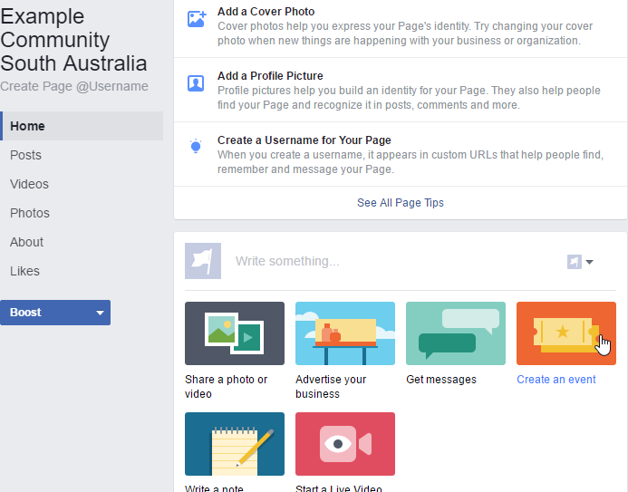

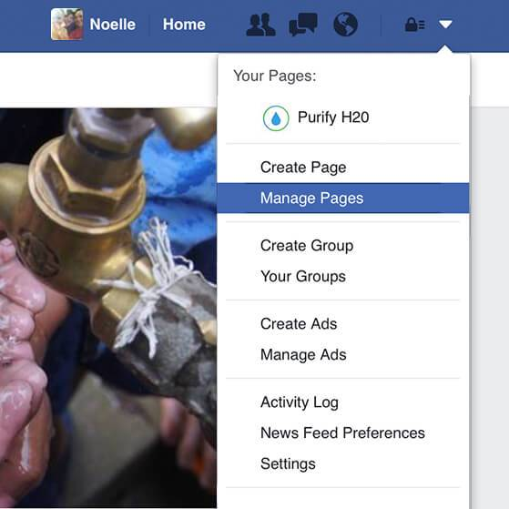**After creating a Page, don’t forget keep checking it:**

By clicking the arrow in the top right of any page on Facebook and selecting Manage Pages.

Make sure you keep updating your page, especially before and events, to help keep your followers engaged!