# HOW TO CREATE A FACEBOOK GROUP IN 8 STEPS

#### Step 1: Create Group

To create a Group, log into your personal Facebook account.   
Click the arrow in the top-right corner of any page and then   
select Create Group.

#### Step 2: Name group and add people

Type a **name** for your group, then type the **names** of friends you want to add to the group; suggested friends will appear as you type. You can click a suggestion to add that friend.

#### choosing a group privacy settingStep 3: Set privacy

Choose a privacy setting for your group. There are three privacy options: Open, Closed, and Secret.

Once you’ve done that, click ‘Create.’

#### Step 4: Choose an icon

Finally, choose an icon for the group, then click OK. You can also skip this step if you prefer.

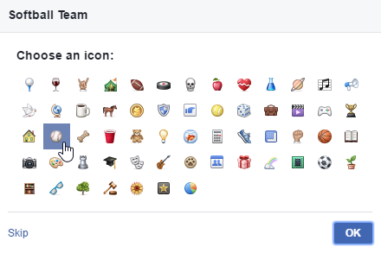

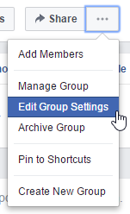  
  
Step 6: 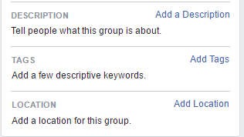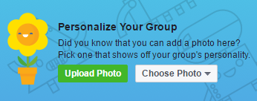Edit Group Settings

#### Step 5: Add information about your group

Once the group is created, you’ll be taken to the group main page. Here you can add some basic info.

Add a Photo – Make the group page look lively by adding a photo if you have one

Add a Description – Over here, write the reason for making the group. That way, when you add new people they will understand what the group is for.

Add Tags – You can connect your organisation to existing categories on Facebook. This feature is optional.

Before you start adding members, it is a good idea to review the group’s settings

#### Step 6b: Choose how members are added

On the Group Settings page, you can add more information about your group and choose how members are added.

Membership Approval – If you want to keep the group small for privacy or working reasons, change this setting to “Any member can add members, but an admin or moderator must approve them.’ This will help keep unwanted members or spammers out.

Click Save when you are done.

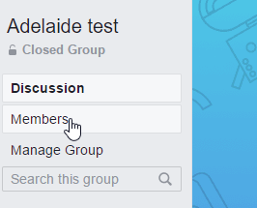

#### Step 7: Add members!

You can add members in several ways. The easiest is to   
click on Members on the left-hand side of the page.

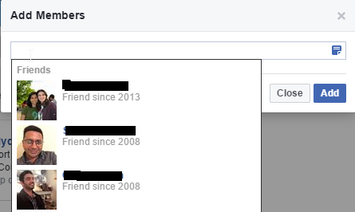

+Add – Click on this button to search for members to add

#### Step 7a: Enter their names of email-addresses

As you start typing, you will see their pictures pop up if they are on Facebook. Click on the person’s picture name. Repeat this step for all the people you want to add on the group. When you are done, don’t forget to click the blue Add button.

#### Step 8: Engage your group

You are now done with setting up the group and adding members to it! Now you should welcome members and post content to get the group started.

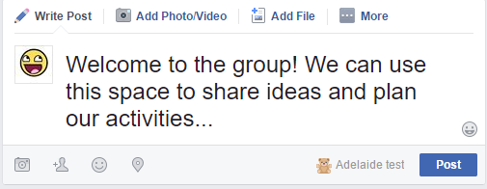

Write posts - It’s best to lead by example, so make sure you’re posting and commenting in your group and encouraging your members to as well.

Share photos/videos – People enjoy seeing photos and videos! They are a great way to keep members interested and start discussions.

Reply to comments and posts – You should check the page according to a schedule and make sure to reply to members questions and comments.